Southeast Wyoming Burn Surge Annex

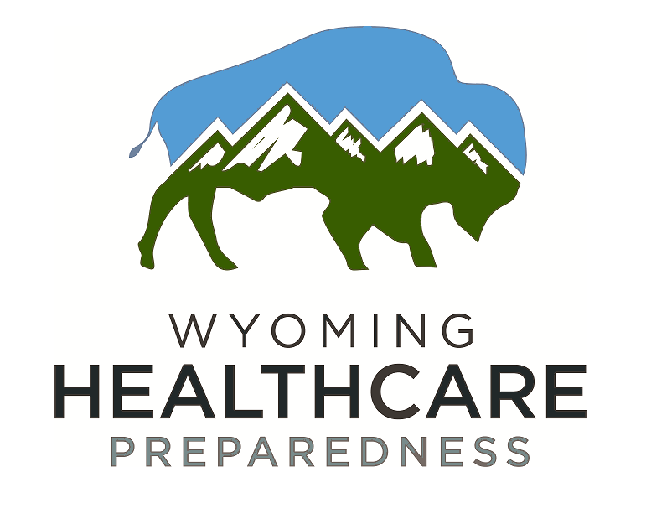

Table of Contents
Introduction
1.1 Purpose
1.2 Scope
1.3 Overview/Background of SEWYHCC and Situation
1.4 Access and Functional Needs
Concept of Operations
2.1 Activation
2.2 Notifications
2.3 Roles and Responsibilities
2.4 Logistics
2.5 Special Considerations
2.5.1 Behavioral Health
2.5.2 Decontamination
2.5.3 Evacuation
2.5.4 Special Pathogens
2.5.5 Security
2.6 Operations- Medical Care
2.6.1 Triage
2.6.2 Treatment
2.7 Transportation
2.8 Tracking
2.9 Reunification
2.10 Deactivation and Recovery

1. Introduction
  - Purpose
This annex applies to a mass casualty event with a large number of burn patients. It supports the SEWYHCC Response Plan by addressing specific needs of burn victims and supporting appropriate burn medical care during a disaster. This plan is intended to support, not replace, any existing facility or agency policy or plan by providing uniform response actions in the case of an emergency that involves (or could involve) significant numbers of burn victims.

  - Scope
Upon activation of the SEWYHCC Plan, the SEWYHCC Command may designate the SEWYHCC Medical Advisor and/or Operations or Planning Section Chief to coordinate the medical and public health aspects of burn surge management.
The designated SEWYHCC staff will, in turn:

1. Coordinate with local Emergency Management Agency Directors and partners to establish a schedule for conference calls and situation briefings
2. Communicate with local, state, and other law enforcement authorities, as necessary, to coordinate procedures for evidence handling and preservation, and coordinate the medical and public health content of advisories to regional first responders, hospital staff, coroners, and other responders
3. Initiate communications with designated staff responsible for providing guidance on burn management
4. Coordinate with the SEWYHCC Behavioral Healthcare Advisor the need for and delivery of services relating to counseling for response agency personnel and their families.
5. Coordinate with Trauma Surgeons/Pediatricians for care and transfer of patients to proper care and response.
6. Prepare a Burn Surge Management Action Plan for the initial and subsequent Operational Periods, identifying the medical and public health actions necessary to the effective management of patient care.

  - Overview/Background of SEWYHCC and Situation
SEWYHCC:
  - Comprised of hospitals, EMS, LTCF’s, Emergency Management and many other partners
  - Cheyenne Regional Medical Center is a Level III verified trauma center with neurosurgery capabilities.
  - Ivinson Memorial Hospital, Laramie WY, is an area trauma hospital. Torrington Community Hospital and Platte County Memorial Hospital are both Trauma Receiving Facilities
  - Burn Hospitals will be consulted for cases needing more specialized care by following EMTALA
  - Patient transport resources for inter-facility transfer of patients including pediatric burn patients.
  - Local ALS ambulance services as well as rotor and fixed wing flight services can transfer patients.
  - Located within a rural community, hospitals are limited with the number of patients they would be able to care for in the event of a surge. In some situations, a very small number would stress the system.
  - Access and Functional Needs
Burn care, not normally available at some hospitals, may have to be provided during a disaster until transfer for definitive care can be arranged. Healthcare providers, not used to caring for critically ill or injured burn patients may have to provide initial stabilization and continued care, until the patient can be transferred.

There is not a burn hospital located within the boundaries of the SEWYHCC.
2. Concept of Operations
2.1 Activation
Individual facilities can activate via notifying the SEWYHCC Coordinator. The Coalition’s role is strictly consultative.
2.2 Notifications
The coalition coordinator or designee will consult with the local ESF-8 and, if necessary , begin the process of notifying all coalition members using the eICS system, which is regularly tested.
Notification of activation should include details of the event requiring activation, scope of the emergency, entities affected and agencies that are responding. If possible, follow up notifications should include the roles and responsibilities that are required to be filled and include a process for recipients to confirm their availability to provide support.
2.3 Roles and Responsibilities
The coalition coordinator or designee will consult with incident command to determine roles and responsibilities.
2.4 Logistics
The coalition coordinator or designee will consult with incident command to determine operational mission areas defined below:
SEWYHCC, through eICS, can request resources needed to all members within the coalition. When the needs cannot be met within our region, requests can be sent to other coalitions/facilities within the state through the same system. Table 2.4 outlines the phases of needs within the coalition.
2.4.1 Space In the event of a burn surge, facilities can utilize the following locations for overflow:
•Conventional spaces: The use of other areas of a facility can be used, such as a physician’s office, pre-op centers or other areas that would meet the needs to provide care.
• Contingency spaces: Consideration can be made to transfer adult rooms to burn rooms or using closed units within the facility. Discharging ED and inpatients as soon as feasible and safe. Establishing a discharge holding area or using hallways for overflow.
• Crisis spaces: The use of varied providers to supervise patient care, alternate care locations including temporary intensive care/ventilator support for patients who cannot be moved. Utilize faith-based facilities or schools as alternate treatment areas.
2.4.2 Staff
Burn care considerations can be such as calling in additional staff to manage patient care of less critical patients while those who are burn trained may take a larger number of more injured or high-level care needs patients. Implementing telehealth measures with burn specialists to provide guidance and care recommendations until patients can be transferred to appropriate levels of care.
2.4.3 Supplies
Facilities should evaluate on a regular basis supplies, including medications and delivery devices needed that are age-appropriate in the event of a pediatric burn surge. SEWYHCC cache supplies should include pediatric supplies and if not available, requests will be made to other facilities within the state. Facilities should also evaluate on a regular basis supplies, including fluids, gauze, and any other needed burn specific supplies in the event of a surge in burn patients.
2.5 Special Considerations
2.5.1 Behavioral Health
SEWYHCC partners include Behavioral Health, who will be notified of any needs to help support mental health services for victims, caregivers, and providers. Social workers, counselors, businesses will be included in the support and safety role.
2.5.2 Decontamination
Facilities will ensure decontamination processes meet the needs of burns decontamination and will practice these processes through exercises and drills.
2.5.3 Evacuation
Evacuation processes will be coordinated including Burn Intensive Care Unit with facilities and specialty partners outside coalition boundaries with agreements currently in place.
2.5.4 Special Pathogens
Burn patients who are exposed/potentially exposed to a highly infectious disease will be managed in a way to minimize exposure to others including health care providers and caregivers .
2.5.5 Security
Security will be increased to help with reunification, securing safe locations for burn patients, and ensuring proper reunification with family. Protecting against kidnapping and for younger victims and ensuring locations are pediatric safe will be worked into planning for pediatric events at each facility. Law enforcement and liaisons such as child protective services will be contacted as needed to ensure the safety of pediatric patients in a burn surge situation, as well as those patients without family on site or critically injured patients.

2.6 Operations- Medical Care
2.6.1 Triage
EMS and Emergency Department staff will triage burn patients and determine priority of care appropriately. Burn patients will be stabilized, and consultation will be made with the burn specialty team on continued care and transport decisions. Psychological triage will be performed to assess any high-risk patients and their need for additional resources and care.

2.6.2 Treatment
Burns specialty team will be consulted to determine level of care needed, transportation and which facility can best meet the needs of patient care and outcome. Consultation can be made via telehealth.

2.7 Transportation

Transportation will be determined using the Burns Specialty team to determine the level of care needed. The appropriate dispatch center will coordinate air and ground transportation.

2.8 Tracking
Tracking of patients will be done through the facility. A designated person for each facility should be assigned to ensure proper tracking of patients. This will allow all facilities to track patients for family reunification and other entities.
2.9 Reunification
Each facility will have a reunification location within their facilities as well as a process for releasing patients to family or other services needing to care for the patients. The location for reunification must be staffed to support care and a safe environment for these patients until they can be reunified with family members or appropriate entities.
2.10 Deactivation and Recovery
Deactivation and Recovery will be based on Table 2.1 and continued reassessment of the situation. Incident Command will begin the deactivation and assess needed resources for recovery, including behavioral health.

SEWYHCC Burn Surge Annex
Introduction
This Healthcare Coalition Burn Annex is being developed for the SEWYHCC. It is not the intent of this document to suggest patient care practices at any hospital or recognized verified burn center.

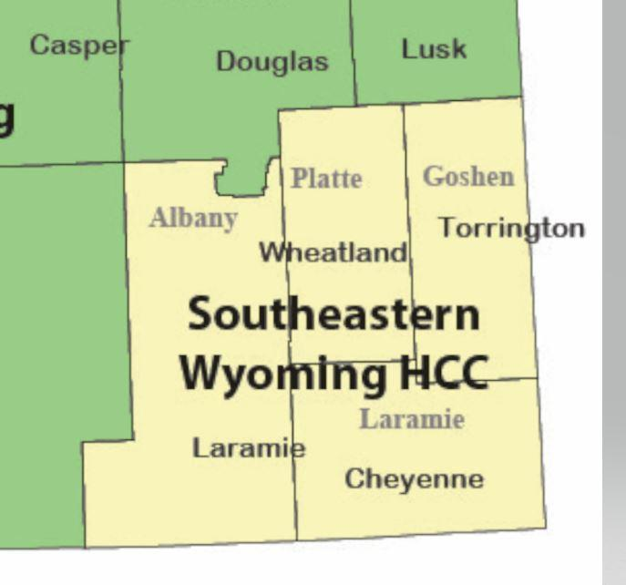
- Definition of Mass-Casualty Burn Incident
Any catastrophic event in which the number of burn victims exceed the capacity of the local burn center to provide optimal burn care. Capacity is availability of resources to include burn beds, burn MD’s, burn RN’s, OR’s, equipment, supplies, and related resources.
- Concept of Operations
  - Scenario Process
  - 911 call – initial communication with receiving ED – Cheyenne Regional Medical Center or Burn Centers in CO.
  - Burn Center to determine significance of event as they communicate with ER and ER continues communication with first responders at the scene.
  - Local burn center activates their Burn MCI surge plan as indicated by the extent of the incident.
- Communication with local and regional partners
  - Local hospitals to Burn Specialist Team- Burn Center
  - Reach State Partners (further identify state players/plans)
  - Reach out to ABA resources and national partners
- Burn center in the region impacted by the incident reaches out to Western States Burn Center as a logistical coordinating center.
970-356-9020

American Burn Association Triage Recommendations:
- Triage major burn to a burn center within the first 72 hours
- Secondary triage may occur from burn center to burn center (regional or national
- Transfer to verified burn centers is preferable

Initial Field Management
Regional Burn Center Contact List:
• Children’s Hospital Colorado Burn Center – 720-777-3999
• Swedish Medical Center- Burns and Reconstructive Centers of Colorado- 855-863- 9595
• University of Colorado Hospital Burn Center – 1-844-285-4555

