# April - June

# January - March

# October - December

# July - September

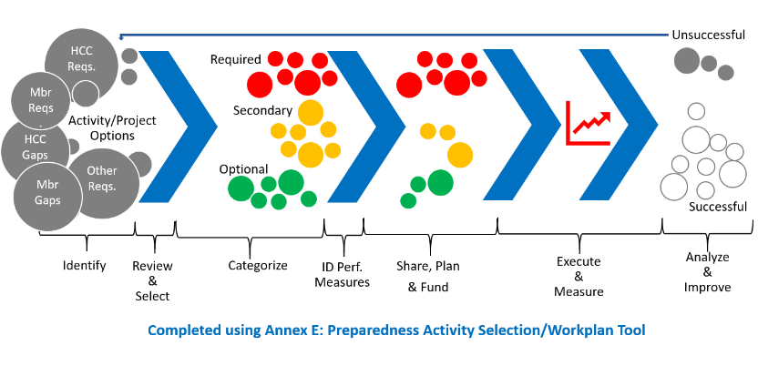

**Review Preparedness Plan**

**Review Other Plans (as needed)**

**Desired Outcome:** All plans are reviewed, updated, ratified, and disseminated annually. Plans are updated after HVA/Gap as this ensures efficacy of plans but before activity selection so all activities support HCC plans.

**Activity Selection (for next year)**

**Desired Outcome**: Using HVA/Gap analyses, and in supporting approved plans, next year’s preparedness activities such as improvement initiatives, development of plans, training, exercises, etc. are:

* Identified from various members and sources
* Triaged, selected and categorized
* Planned, resourced and performance monitored
* Executed and monitored
* Measured and improved

**HVA Review**

**Gap Analysis Review**

**Desired Outcome**: HVA and Gap analysis are updated and can be used to accurately review plans in Q2 and to plan/execute preparedness activities.

**Policies, MOUs, Letters of Support, and other Review**

**Desired Outcome:** All policies, documents, formal agreements, and other coalition documents are reviewed, updated and re-ratified each year. Active solicitation of formal agreements with members and partner executives is solicited.

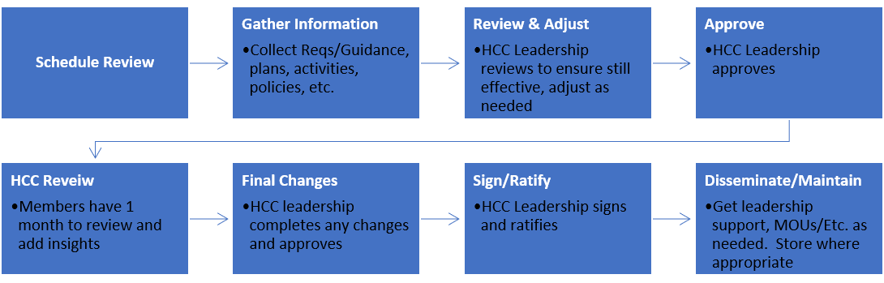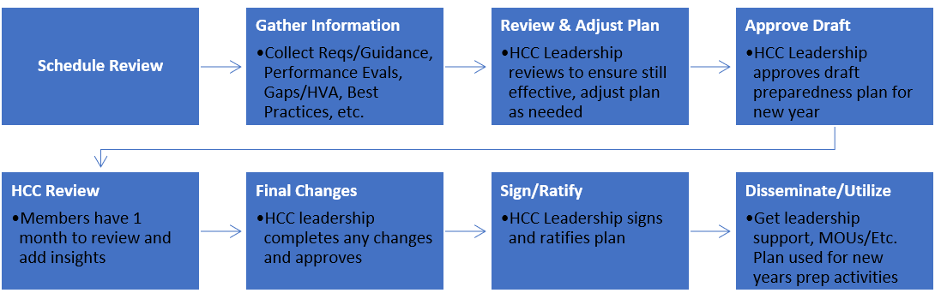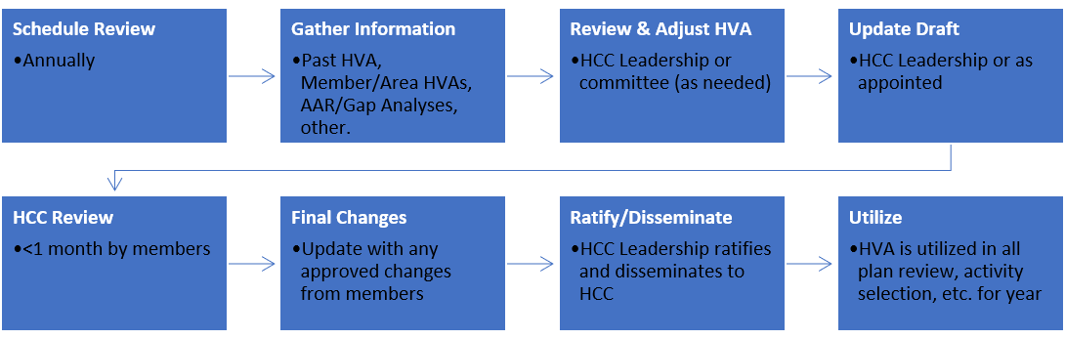

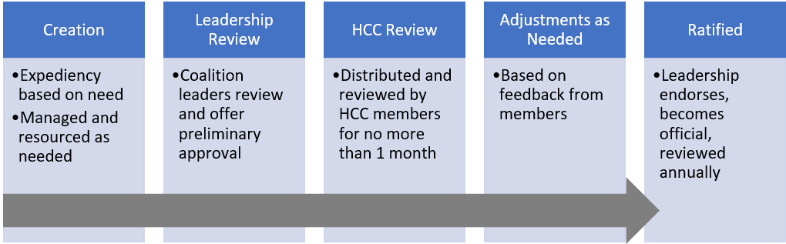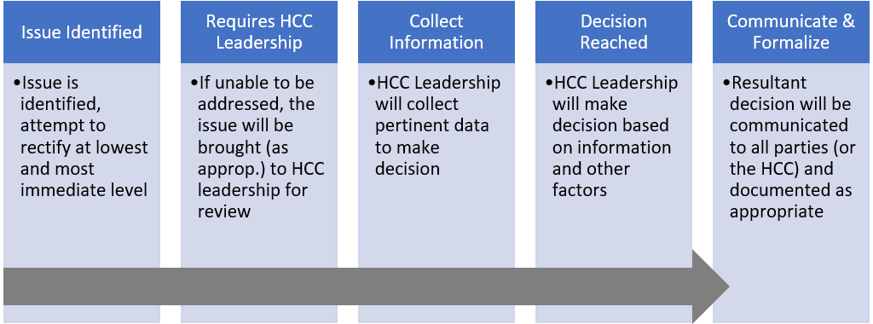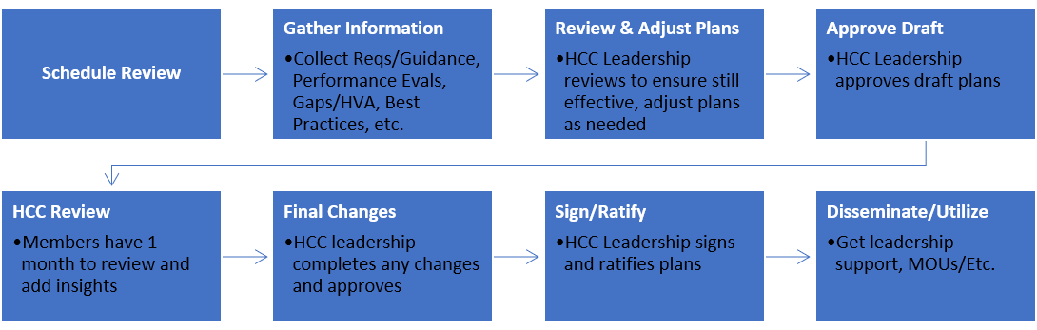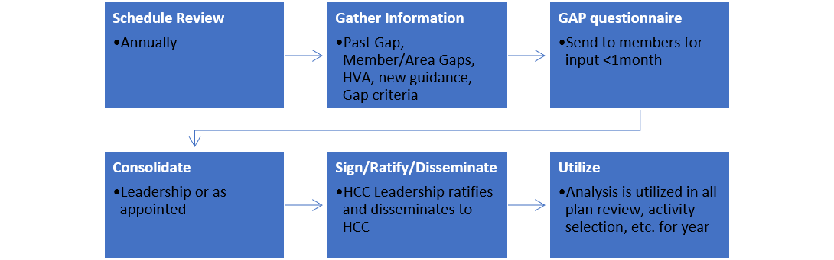

# Throughout Year

* Use Annex E to identify, categorize and determine annual performance activities.
* Plan and resource (funding, material, locations, vendors, etc.) selected activities.
* Establish performance outcomes for activities.
* Execute preparedness activities.
* Measure outcomes, share and/or improve as needed.

**Recruit Members**: Done by offering: 1) Access to training, seminars, exercises, and other preparedness resources. 2) Support with regulatory requirements. 3) Cost sharing. 4) Networking and partnership opportunities. 5) Access to best practices, data, and other information. 6) Mitigation and response strategies that lower financial, operational, and other impacts. 7) Promoting a shared commitment to protect the health and welfare of the citizens and communities.

**Coordinate Activities with Members, ESF8, OEM, others:** Done through: 1) Solicitation for membership and participation. 2) Requiring positions on the coalition to be filled by these groups. 3) Collecting funding, regulatory, operational, and other requirements, activities, intentions, etc. in plan review, activity selection, and other processes. 4) Involvement in planning, execution, and monitoring/measurement of preparedness activities. 5) Communicating coalition meetings, activities, projects, etc.

**Maintain/Sustain Coalition:** In recruitment, meetings, plans, etc.: 1) Discuss complexity of medical response 2) Communicate HCC purpose, mission and role. 3) Share vale of membership 4) Share benefits to region. Sustain HCC by: 1) Adhering to benefits offered in recruitment (above) 2) Being financially responsible 3) Discovering and sharing best practices 4) Engaging executives, clinicians, community leaders, and representatives from at risk populations in all preparedness activities.

**Utilize Formal Agreements:** As needed, and utilizing document that best fits need, activity seek and utilize mutually supportive formalized agreements (MOUs, MAA, Letters of Support, etc.)

**Make Decisions: Create Policies & Plans: Execute and Monitor Preparedness Activities:**