Geography

The following geographical area is served by our healthcare coalition:

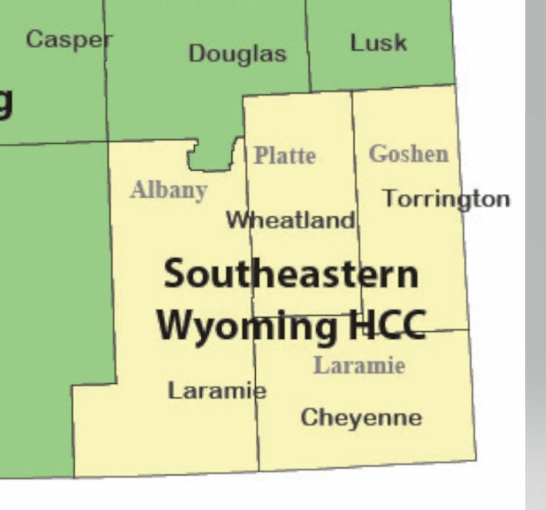

Jurisdictions, Entities, etc.

The following jurisdictions, tribal nations, unique entities, and other special groups are served by our coalition:

Laramie County, WY | Platte County, WY | Goshen County, WY
Albany County, WY | University of Wyoming | Warren Airforce Base

Routine Healthcare Operations

Within our healthcare coalition, routine healthcare is provided through the following format:
- Routine/day-to-day care is provided by physician practices, long term care facilities, home health entities, and other out-of-hospital providers in each of our 4 counties.
- Low acuity hospital patients (i.e. patients hospitalized for non-emergency needs, existing health conditions, post-operative care, etc.) are treated at critical access and other acute hospitals:

  - Cheyenne Regional Medical Center; Cheyenne, WY. Regional Trauma Center (reference ACS Level II/III) (verified ACS Level III)
  - Ivinson Memorial Hospital; Laramie, WY. Community Trauma Hospital (reference ACS Level IV)
  - Platte County Memorial Hospital; Wheatland, WY. Trauma Receiving Facility
  - Community Hospital; Torrington, WY. Trauma Receiving Facility (Provisional)

- Medium acuity hospital patients are generally treated at the sites listed above or sent to Cheyenne Regional Medical Center; Cheyenne, WY or Ivinson Memorial Hospital; Laramie, WY

- High acuity patients are generally treated at Cheyenne Regional Medical Center or sent to facilities in Fort Collins, CO; Casper, WY; Scotts Bluff, NE; Denver, CO; Greeley, CO.

- Pediatric high acuity patients are sent to Denver, CO.

- Burn patients are sent to the Northern Colorado Burn Center, Greeley, CO.

- Several areas of the coalition operate volunteer EMS agencies with EMT-B/I service providers. Cheyenne, Laramie and Torrington are the primary cities that provide advanced life support (ALS) EMS services.

Unique Operational Boundaries and Considerations

Encompassed in these geographical, jurisdictional, and operational considerations are the following unique considerations, patient needs, etc. included in the scope of this preparedness plan and the activities of the coalition.
- The first is the relationship between our coalition and Warren Airforce Base. As our coalition offers the primary medical capacity in the area, and staff from Warren AFB travel throughout Wyoming servicing federal and DOD installations, we must include considerations for these potential patients in an emergency.

- Secondly, our coalition does operate one of two major acute healthcare treatment facilities in the state (Cheyenne Regional Medical Center). As such, our coalition frequently receives patients from rural areas in Wyoming for medium to higher acuity treatment needs.

