Southeast Wyoming Healthcare Coalition

**Radiation Emergency Surge Annex**

**Table of Contents**

**1 Overview**

**1.1 Introduction**

**1.2 Scope**

**1.3 Overview/Background of HCC and Situation**

**1.4 Assumptions**

**2 Concept of Operations**

**2.1 Medical Operations Coordination**

**2.2 Activation and Notifications**

2.2.1 HCC Activation and Notifications

2.2.2 State Activation and Notifications

2.2.3 Regional Activation and Notifications

**2.3 Roles and Responsibilities**

**2.4 Logistics**

2.4.1 Space

2.4.2 Staff

2.4.2.1 Radiation Exposure Care Training Resources

2.4.2.2 ICU Augmentation

2.4.2.3 Rural Clinical Care Strategies

2.4.3 Supplies

2.4.3.1 Radiation Supplies

2.4.3.2 Resource Request Coordination

**2.5 Operations: Medical Care**

2.5.1 Triage and Screening

2.5.2 Patient Care/Management

2.5.3 Treatment

2.5.4 Safety and Control Measures

2.5.5 Fatality Management

2.5.6 Transport

2.5.7 Surveillance, Tracking, and Situational Awareness

2.5.8 Rehabilitation, Outpatient Follow-Up Services

2.5.9 Deactivation and Recovery

**2.6 Special Considerations**

2.6.1 Behavioral Health

2.6.1.1 Mental Health Screening and Treatment

2.6.2 Pediatric and At-Risk Populations

2.6.2.1 General Planning Aides

2.6.3 Communications

2.6.4 Jurisdictional – Special Considerations

2.6.5 Crisis Standards of Care

**3 Appendices**

**3.1 Training and Resources**

**3.2 Legal Authorities**

**3.3 Additional Resources/References**

# Overview

This document represents the radiation patient surge plan for the Southeast Wyoming Healthcare Coalition (SEWYHCC). This document is intended to offer general guidelines from which partner agencies can tailor their response to a radiation surge event.

## Introduction

A radiation emergency mass casualty incident is any incident where capacity and capability significantly compromise patient care, following local, state, regional, or federal disaster response plans. Additionally, several small, simultaneous incidents within a locality or region may also amount to a Radiation Exposure MCI if taxing on staff, facilities, or resources. Radiation exposure care is limited, therefore, is likely to exceed the resources of a single jurisdiction and will require surge measures in multiple facilities and possibly engage a broad array of state, regional, and national stakeholders, depending on the scope of the incident.

This plan is intended to be flexible to fit the needs of the response, covering all aspects of a tiered approach to a response from the local level up to federal assistance as necessary. It contains guidelines for radiation surge events in SEWYHCC facilities, including resources for staff training and augmentation, supplies and equipment, and special considerations. The plan was developed in consultation with federal guidelines and requirements for all healthcare coalitions.

Federal guidance provides more detail on the necessity and content of this plan. The 2019-2023 HPP Funding Opportunity Announcement (FOA) requires Healthcare Coalitions (HCCs) to develop a complementary coalition-level radiation emergency surge annex to their base medical surge/trauma mass casualty response plan. This annex aims to improve capacity and capabilities to manage exposed or potentially exposed patients during a radiation emergency. According to the 2017-2022 Health Care Preparedness and Response Capabilities, “Communities should be prepared to manage exposed or potentially exposed patients during a chemical or radiation emergency. During such events, individuals may go to various health care facilities, police and fire stations, and other locations for assistance...” (Capability 4, Objective 2, Activity 5).

This annex provides guidance to support a Radiation Exposure MCI in which the number and severity of exposed or potentially exposed patients exceed the capability of SEWYHCC healthcare facilities. The annex identifies the resources (both within and external to the SEWYHCC) that must be engaged in a Radiation MCI response.

The overarching goal is to ensure the highest standard of care possible for the greatest number of patients during a radiation exposure surge event, with the following objectives:

* Plan and coordinate activations, notifications, logistics, and resources;
* Recognize roles, responsibilities, and organizational structure; and
* Solidify operations, including triage, treatment, and transfer flow and support.

## Scope

This annex is intended for use by the SEWYHCC to assist in providing coordination during a radiation exposure surge event. The primary focus is on identifying resources for local, regional and national coordination as they care for patients exposed or potentially exposed to radiation.

This document is intended to support, not replace, existing policies and plans by providing uniform response considerations in the case of a radiation emergency. This plan will utilize existing command structures and communication protocols. Internal documents and policies that address specific organizational responses impacting radiation emergencies will be provided to participating parties.

The response strategies and processes described herein do not supersede the authority of participating entities. A coordination body is intended to assist healthcare systems when overwhelmed by leveraging resources and supplies to assist in treating and transferring patients.

## Overview/Background of HCC and Situation

The response strategies and processes described herein are not legally binding, and there is no legal obligation to participate. However, participation by hospitals, healthcare systems, and their partners is encouraged to ensure the best possible outcomes for patients treated in the jurisdiction. The plan leaves the majority of the decisions and processes up to the healthcare systems and transfer centers. The processes outlined herein do not supersede local or state protocols and will be implemented only when requested or required.

The coalition’s geographical and jurisdictional boundaries encompass four counties, Albany, Goshen, Laramie and Platte, comprising a vast area of Southeast Wyoming, covering 11,340 square miles with a population of 158,344 people which computes to a population density of 13.9 per square mile.

**Exploitable Sources of Radioactive Contamination**

A terrorist could obtain radioactive material from one of several different sources. The following list of potential exploitable is adapted from US Army Center for Health Promotion and Preventive Medicine Technical Guide 238, Identification of Radiological Sources of Potential Exposure and/or Contamination (Falo, Reyes, and Scott, 1999):

* Radiation Sources and Contaminants Found in Nature
* Radiation Sources Related to the Nuclear Fuel Cycle
* Radiation Sources Used in Medical Diagnosis and Therapy
* Radiation Sources Present in Military Equipment
* Radiation Sources Used in Industry
* Radioactive Equipment and Materials Which May Require Transportation

## Assumptions

This Radiation Exposure Annex Assumes the Following:

* Radiation incidents may be accidental in nature (e.g., industrial or transportation accident) or purposeful, require prolonged response and extensive resource management challenges.
* Substantial differences in response protocols and priorities exist between power plant / industrial, terrorist (e.g., RDD/dirty bomb) and nuclear bomb detonation. The plan should emphasize the scenario(s) most relevant to the community.
* The coalition annex does not replace the need for protocols at each hospital and EMS agency
* Different agencies may have authority over management of power plant, transportation, and terrorist incidents, including the authority to implement shelter-in-place and evacuation orders.
* The roles and responsibilities of agencies and organizations will change depending on the severity and scale of the incident and the respective level of activation by impacted jurisdictions and should be outlined ahead of an incident.
* Federal, state, and local emergency resources will all be needed during a large-scale event.
* Contamination assessments, proper PPE utilization, and decontamination efforts will be essential in protecting coalition partners, staff, and the public
* Staff at coalition facilities may be impacted by exposure, fear of exposure, or family obligations (e.g., child/family care if schools are closed, acute care facilities are affected).
* Fear from the incident will cause a worried well surge to the emergency departments and pharmacies. Consider how limited understanding of radiation and nuclear contamination will contribute to public anxiety and will require multi-modal solutions.
* Public safety (e.g., police, fire, EMS) and other first responder personnel are considered a highrisk population; the implementation of protocols for monitoring control zones and effective contamination control measures will be essential for workforce protection.
* Federal resources (e.g., ambulance contracts, National Disaster Medical System [NDMS] teams) cannot be relied upon to mobilize and deploy for the first 72 hours.
* Management of contaminated waste from decontamination efforts should be managed in consultation with SMEs, EPA, and local water authorities.

**The following assumptions provide the basis for the emergency response procedures outlined within this plan. It is expected that all participating facilities and supporting agencies are aware of the following:**

* Implementation of surge protocol specific to a radiation emergency will occur quickly- staff must be prepared to pivot operational procedures immediately.
* Initial trauma care should precede radiation injury management.
* Radiation contamination assessments will require rapid protocol and education implementation. Staff will need to evaluate real versus possible exposure, internal versus external contamination, and assess overall exposure levels for at-risk patients based on serial blood testing.
* Specialized expertise (such as clinical advisors) will be needed to manage the complexities of a major radiological incident (e.g., dose estimation, exposure type, treatment plans, site evaluations, decontamination protocol).
* Contaminated injury care and decontamination may require rapid expert consultation.
* Community screening sites will be required to assess low-risk patients.
* Depending on the scale of the radiological event, it may be necessary to establish alternate care sites, especially for radiological exposure requiring higher levels of care.
* Emergency departments, outpatient care centers, and alternate care sites, must be prepared to rapidly screen large groups of potentially exposed individuals, triage, and transport as needed. • Allocation of limited/scarce resources, and their distribution, should be based on agreed upon prioritization systems / methods.
* Large-scale radiological incidents may require the recruitment of volunteers (e.g., Medical Reserve Corp), retirees, and trainees to support and relieve screeners and healthcare workers.
* Some individual healthcare facilities may require large-scale fatality management support.
* Community-based interventions will require significant public health effort if an evacuation or shelter in place order is necessary. Critical infrastructures will be impacted (e.g., food distribution, isolation assistance, surveillance activities).
* Health concerns, prolonged response requirements, difficult work environments, and stress may present behavioral health challenges among staff of coalition members and the general public.
* Rural areas may be severely impacted by citizens fleeing an affected area and seeking care.

# Concept of Operations

## Medical Operations Coordination

Federal guidance advocates the use of one or more Medical Operations Coordination Cells (MOCCs) to assist in an incident that overwhelms the capacity of hospitals in a given area. The *Establishing Medical Operations Coordination Cells* webinar, delivered by the Assistant Secretary of Preparedness and Response, provides the following general description of MOCC utilization:

* Some hospitals are overwhelmed with radiation exposure patients, while successful mitigation has created excess capacity in nearby hospitals, creating an opportunity to transfer patients.
* MOCCs are a strategy to optimize patient distribution by augmenting EOCs with clinical experts that synthesize and coordinate healthcare capacity.
* The MOCC strategy can be implemented nationwide (at sub-state, state, and regional levels), permitting flexibility for states while optimizing patient distribution.

To meet the goal of best possible patient outcomes after a radiation emergency, the SEWYHCC, if overwhelmed and requiring assistance outside of the jurisdiction, will request state health representatives authorized to establish a sub-state or state MOCC to help coordinate patient transfer and resource sharing. The following steps outline the potential flow of activations and responses during a Radiation Exposure MCI:

1. A mass casualty incident involving radiation exposure occurs. The local 911 system is activated.
2. Local EMS begins notifications, patient triage, decontamination, and distribution from the incident scene per existing protocols and typical “hub and spoke” procedures. Local receiving facilities notify SEWYHCC to assist with coordination, decontamination, and resource sharing.
3. If local response agencies and the HCC are overwhelmed, state assistance is requested. A sub-state or state MOCC is activated to work with transfer centers to help inform in-state patient distribution and resource coordination.

Additional details for activation, notification, and the roles and responsibilities of each level of the response are provided in the sections below.

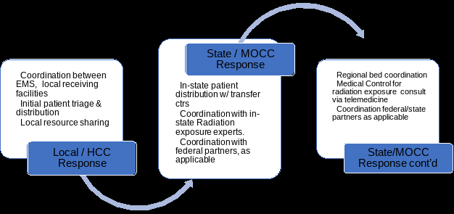

## Activation and Notifications

### HCC Activation and Notifications

The SEWYHCC can be notified of a BMCI by any SEWYHCC member. The SEWYHCC Radiation Emergency Surge Annex is activated by contacting the SEWYHCC Healthcare Readiness and Response Coordinator (HRRC), using the following steps, in descending order, until successful contact is made.

Upon notification and Radiation Surge Annex activation, the HCC will notify all SEWYHCC members using the Juvare notification system.

### State Activation and Notifications

Sub-state and state MOCC activation will occur by contacting David Edwards, Hospital Preparedness Program Manager, Wyoming Department of Health, using the following steps, in descending order, until successful contact is made. They can also aid in the decision of utilizing federal level resources.

1. Phone call: 307-777-6904
2. Secondary phone call or text message: mobile phone number (SEWYHCC Board of Directors and HRRC are in possession)

### Regional Activation and Notifications

When a medical surge beyond local capacity is anticipated, the SEWYHCC will call additional resources based on the ESF-8.

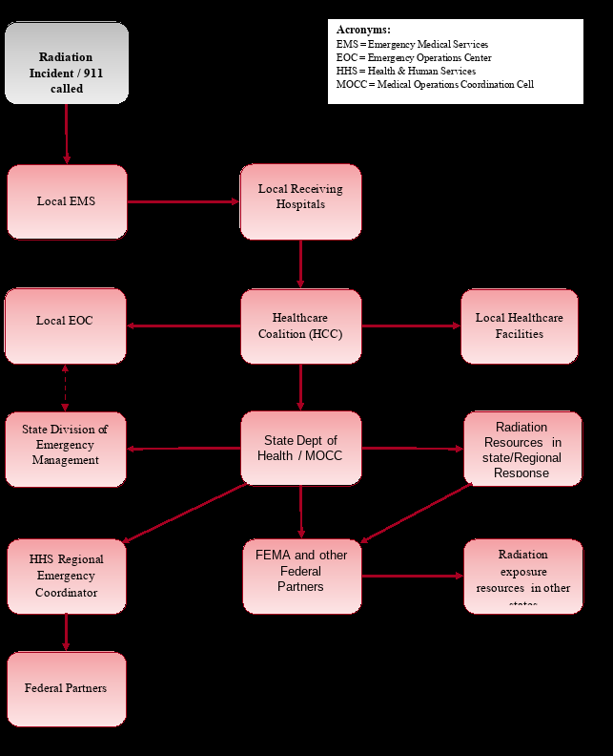

## Roles and Responsibilities

Local organizations and agencies within the impacted jurisdiction will have primary responsibility for response, including initial triage and casualty distribution. Suggested response roles for local, state, and national stakeholders and partner agencies are summarized below.

| **Partner** | **Roles and Responsibilities** |
| --- | --- |
| **EMS**    **Local Healthcare Coalition**    **Public Health (PH)**    **Emergency Management (EM)** | * Rescue, transport, and distribute casualties to appropriate local facilities. * Request and mobilize any coalition or regional caches of radiation exposure supplies. * Activate coalition coordination mechanisms and any radiation exposure-specific plans. * Coordinate local lists of casualties and clinical information. * Triage/prioritize patients for transfer to specialty centers under established Radiation MCI protocols and expert input. * Coordinate with radiation experts to determine appropriate destinations for patients that cannot be accommodated in the local healthcare system with assistance from the state. * Assure that appropriate clinical information is relayed between the referring and receiving facilities during the transfer process.   **Secondary Roles**   * Coordinate information with state/federal ABA partners. * Provide Patient Care * Activate facility and regional surge plans to accommodate multiple patients. * Liaison between local response and regional facilities. |
| **State PH/EM** | **Secondary Roles**   * Liaise between local, state, and federal resources. * Decision whether to activate the Regional Response Team. * Support bed polling and matching functions. * Optimize radiation exposure patient distribution and healthcare capacity by augmenting EOCs with clinical experts that assist with coordination * Coordinate radiation exposure resources and supply needs between healthcare systems * Support local jurisdiction with state-level coordination and requests for assistance (e.g., state and federal declarations). * Assure that patient triage, tracking, and transport needs are addressed. * Make requests for radiation exposure care assets, including dressings and other materials from the Strategic National Stockpile (SNS). * Engage Emergency Management Assistance Compact (EMAC) assets to provide inter-state support for transportation, staff, or other logistics. |
| **Sub-state/State MOCC** | As warranted and requested by the local response:   * Conduct bed polling initially and as needed within the region (and request assistance from adjacent regions if necessary). * Assist the affected local designated transfer centers and state PH in determining appropriate patient destinations and transportation. * Assist with the tracking of patient movement, including arrival to destination centers. Provide updates as requested. * Facilitate requests for tissue bank products, graft equipment, and other specialized supplies. * In collaboration with state and regional partners, establish when the Radiation MCI has concluded. * Establish any post-incident system needs and initiate the AAR process. |
| **Federal Resources** | * Assist with connections to topic experts and other federal resources. |

## Logistics

### Space

Patient care areas can typically be divided into three categories: conventional space, contingency space, and crisis space. Due to the absence of specialized healthcare facilities in Wyoming, the only space available for radiation exposure patients is crisis space. In the event of a Radiation MCI, the MOCC can assist in determining the availability of crisis space. If the MOCC determines that the scale of the event warrants additional consultation, state resources will be contacted to assist in locating additional hospital bed space.

### Staff

The HCC Coordinator or designee will consult with the local ESF-8 to determine the most appropriate role for the HCC and the need for additional resources.

#### *Radiation Exposure Care Training Resources*

Before a Radiation MCI, the SEWYHCC highly encourages training from resources such as the Radiation Response Volunteer Corps Development Toolkit <https://www.crcpd.org/page/RRVC>.

#### *ICU Augmentation*

Immediately following a Radiation MCI, SEWYHCC leadership and members should develop strategies for ICU augmentation in the region, such as the following:

* All hospitals should redeploy staff into the emergency department, ICU, and transport
* roles. Hospitals should utilize existing resources and just-in-time training to assist with patient management.
* All non–radiation exposure-receiving facilities should begin to enact alternative ICU strategies in their emergency operations plans to expand ICU capacity and capabilities.
* Remote training and outreach resources should focus on supporting mass radiation exposure casualties across the state in expanding ICU capacity and capability and preparing staff to function in critical care roles.

#### *Rural Clinical Care Strategies*

The MOCC can provide support to rural healthcare providers to increase their ability to care for radiation exposure victims by:

* Maximizing existing real-time telehealth-based provider support for critical care
* Providing healthcare providers with clinical support and training on crucial considerations in radiation exposure care
* Assisting with discharge criteria, outpatient management, and aftercare programming.

### Supplies

#### *Radiation Supplies*

The SEWYHCC will work with all facilities to ensure they are aware of and have access to the supplies and equipment necessary to treat a radiation exposure patient.

#### *Resource Request Coordination*

Hospitals encountering a need for radiation exposure care resources will first attempt to acquire the needed items using their usual or emergency procurement methods. This can be done in collaboration with state, regional, and federal partners. The SEWYHCC will use the following process to ensure a locally-driven, tiered response.

1. **Healthcare Facility/System**

When an unmet resource need exists, the facility will first utilize existing channels within its hospital system to acquire the needed items. If the system cannot meet the request, the local jurisdiction ESF-8 desk or HRRC should be notified.

1. **Local ESF-8 / State ESF-8**

Local ESF-8/SEWYHCC will initiate efforts to obtain the needed items by contacting facilities in their jurisdiction. If unmet, the request is then sent to the State ESF-8. ESF-8 staff or SEWYHCC will make arrangements for any available resources to be sent to the requesting facility. Note that scarcity of resources may prompt prioritization recommendations to be established by local and state health officials, shared with hospitals through disaster communication channels.

## Operations: Medical Care

### Triage and Screening

The impacted healthcare organizations will immediately begin triage and treatment according to local protocols. The EMS and Hospital Triage Flowcharts on the following pages show the response flow from initial on-scene triage to hospital re-triage, including radiation exposure-specific considerations. Consider need to reach out to state radiation experts.

**Radiation-Specific Triage Charts**

<https://remm.hhs.gov/TriageToolscombined.pdf>

**Exposure and Symptom Triage (EAST) Tool to Assess Radiation Exposure After a Nuclear Detonation**

<https://remm.hhs.gov/EAST-tool-notes.htm>

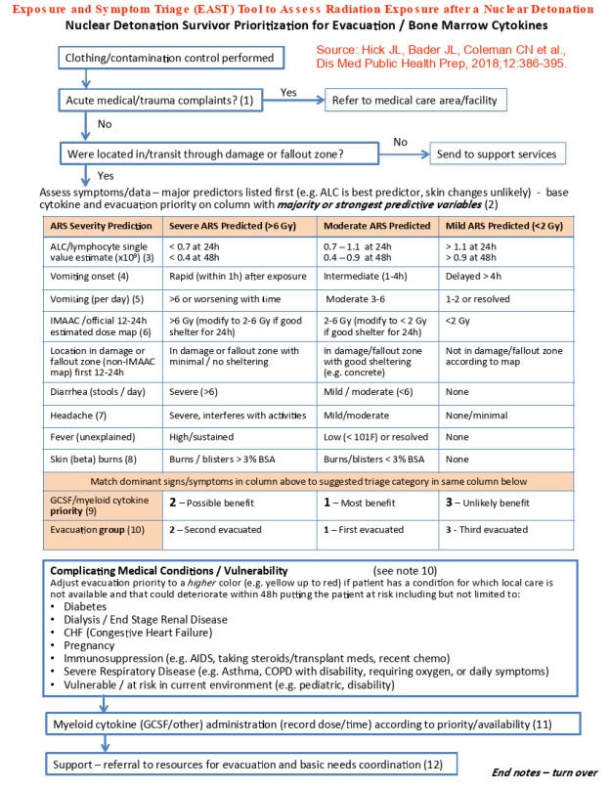

### Patient Care/Management

The SEWYHCC will coordinate with local hospitals, EMS agencies, and other healthcare providers to help develop and implement strategies for maintaining patient care when the system is overwhelmed. Plans should include the ability to shift from conventional to contingency to crisis care and back as the situation requires. Processes that may merit SEWYHCC involvement include:

* Developing guidelines to prioritize treatment or decontamination efforts (e.g., extent of trauma, external contamination counts, partial- or whole-body exposure);
* Assistance coordinating emergency response efforts;
* Coordinating just-in-time training to support care of radiation patients in a limited resource setting;
* Considering how treatment and patient conditions will be documented and shared;
* Assisting in coordination of patient movement, including large numbers of patients with minimal current symptoms but who are at significant risk for complications due to significant radiation exposure;
* Implementing mechanisms to track patients, contamination, lab results, and treatments; and
* Considering the need for palliative care.

### Treatment

The SEWYHCC will coordinate with local hospitals, EMS agencies, and other healthcare providers to determine opportunities to improve patient care. Processes that may merit SEWYHCC involvement include:

* Establishing consultation and coordination mechanisms with hematology, oncology, and radiology facilities;
* Engaging with the Radiation Injury Treatment Network (RITN) and other similar organizations to stay up to date on currently approved treatment protocols;
* Assisting with incorporating established radiation treatment plans (e.g., diagrams, flow charts, and algorithms) to ensure best practice treatment methods; and
* Disseminating information regarding radiation countermeasures, including the request process and guidance for use.

### Safety and Control Measures

The SEWYHCC will coordinate with local hospitals, EMS agencies, and other healthcare providers to determine opportunities to assist with safety and control measures. Processes that may merit SEWYHCC involvement include:

* Supporting local officials with evacuation and shelter-in-place efforts;
* Considering the need for large-scale disposal of contaminated waste from decontamination and patient care operations;
* Considering any special transportation waste management protocols;
* Sharing specific decontamination protocols for self-care, pre-hospital care, community reception centers, and healthcare facilities;
* Coordinating just-in-time training on standard safety measures;
* Assisting local officials in establishing protocolized thresholds for first responder rescue (e.g., >10 mrem/h) and safe zone (e.g., <1 mrem/h) operations.

### Fatality Management

Handling casualties in a mass casualty event can quickly become overwhelming. It is important to note that consideration for how to handle the contamination factors of these casualties should be discussed and plans should be made in accordance with regional experts and ESF-8.

### Transport

A significant limiting factor in a regional response may be the availability of emergency medical services (EMS) transport (i.e., ambulances). EMS support and coordination are essential to the logistical goals of this effort. Note that patient transfer coordination will include step-down transfers and assistance to local authorities as needed for family reunification efforts. Patient movement should occur following local protocols and in collaboration with appropriate state, national, and federal agencies. To expedite the safe, efficient, and appropriate transfer of radiation exposure patients, the SEWYHCC will adhere to the following guidelines.

* Whenever possible, an Advanced Life Support (ALS)/critical care–capable vehicle shall be used to transport a critical patient.
* Hospitals needing to transfer patients to a local Trauma Center should follow their routine EMS transport procedures.
* An individual facility may make arrangements directly or request assistance from local ESF-8 (SEWYHCC).
* The SEWYHCC, in collaboration with Emergency Medical Resource Centers (EMRCs), where applicable, will utilize internal policies and procedures to solicit immediate assistance from EMS agencies.
* If local transport resources have been exhausted or patients need to be transported to another state, transport requests can be made directly to the MOCC.
* Before transporting any patient, facility acceptance for the patient should be confirmed by the MOCC.
* The requesting facility will notify the MOCC of what transportation arrangements have been made.
* The facility arranging air or ground transportation will coordinate with the NOAA National Weather Service for current or future weather conditions. They will gather information for local and en route forecast conditions, including wind speed, ambient temperature, and inclement weather.
* Facilities should utilize aeromedical transportation when available and as weather permits. The facility arranging air transportation will coordinate with aeromedical transports to determine whether medical rotor aircraft can land and take off due to complex conditions (e.g., extremely high temperatures and elevation).

### Surveillance, Tracking, and Situational Awareness

Healthcare facilities will follow routine or disaster protocols for tracking patient movement within their hospital system. The MOCC or may facilitate less common transfers in collaboration with state and regional partners.

### Rehabilitation, Outpatient Follow-Up Services

Patients exposed to radiation often need long term care services and follow-up. This should be discussed with those exposed at time of treatment. Patient tracking software should also be utilized in order to follow-up with the patient post radiation exposure event.

### Deactivation and Recovery

The SEWYHCC will assist in establishing when a Radiation MCI has concluded, in collaboration with other local, state, regional, and federal partners such as the MOCC. Triggers for incident conclusion include decreased patient volumes and near-normal levels of hospital staffing and supplies. The SEWYHCC emergency response personnel will demobilize when these triggers occur and when there is no longer a need for coordinated radiation exposure-specific activities.

The healthcare coalition will initiate the local after-action review process, soliciting and compiling feedback from all responding member agencies. Identified gaps and areas of strengths will be noted in an after-action report, which will be distributed to all relevant agencies and partners. Changes to plans and procedures, including this document, will be based on identified gaps.

## Special Considerations

The following section contains considerations for special populations and special situations, including behavioral health concerns, pediatric patients, combined injuries, and crisis standards of care.

### Behavioral Health

Given the nature and scope of a Radiation Exposure MCI, it can be expected that a number of those who witnessed, were injured by, or responded to the event will experience some mental trauma in relation to the incident. PTSD is more likely to occur if the injury is an assault or a repeated trauma (such as ongoing abuse).

The National Institute for Mental Health strongly recommends a thorough psychosocial screening following trauma exposure to help identify individuals at risk for PTSD. Clinicians need to utilize a trauma-informed approach. They should begin by creating a sense of safety through education about what to expect, orientation to their care team and unit, and reconnection to known coping tools and support systems. It is also important to note that in addition to traumatic stress, many victims also deal with grief from loss (of a home, a loved one, a limb, etc.) and fear that something like this may happen again with little ability to predict or prevent it.

#### *Mental Health Screening and Treatment*

The SEWYHCC will work with member facilities to be prepared to identify and appropriately respond to potential mental health concerns in their patients, patients’ families, and staff. The SEWYHCC advocates for resources and training in “psychological first aid” to help clinicians and emergency response workers understand the victim’s worldview, project a sense of calm, normalize feelings and reactions, provide the information needed to deescalate acute distress, and provide information on next steps.

SEWYHCC facilities will ensure radiation exposure victims treated in the jurisdiction receive mental health screening and treatment in accordance with these recommendations. Facilities will provide patients with information on available radiation exposure survivor support and aftercare programming in the region.

### Pediatric and At-Risk Populations

It is critical that healthcare facilities have the education and resources necessary to assess and treat pediatric patients. A general planning figure is to assume that a minimum of 25% of victims from any mass casualty incident will be children.

The SEWYHCC Pediatric Annex includes detailed information on pediatric care and planning at the coalition level.

#### *General Planning Aides*

The PedsReady Emergency Department Checklist, with a goal to ensure emergency departments are set up to appropriately care for the pediatric patient, is available online. It is additionally recommended that HCC members take the online FEMA Independent Study course *IS-366: Planning for the Needs of Children in Disasters*.

Additionally, the Western Regional Alliance for Pediatric Emergency Management (WRAP-EM) has an extensive collection of pediatric resources available online. A new resource for pediatric behavioral health is *Psychological Simple Treatment and Rapid Triage (PsyStart)*. This system offers real-time triage and case management for children affected by a disaster. Contact Dr. Merritt Schreiber at m.schreiber@ucla.edu to access the system.

### Communications

Combined injury (i.e., radiation exposure in addition to other trauma, burns, or chemical injuries) markedly increases mortality. These patients may be better served at trauma and other centers depending on the severity of each injury. Expert clinical input should support decision-making, including decontamination considerations if radiological or chemical agents are involved. Initial triage by EMS should always focus on traditional trauma triage guidelines when trauma is present, and secondary triage providers will need to consider the combined injury.

### Jurisdictional – Special Considerations

### Crisis Standards of Care

An overwhelming public health emergency, such as a Radiation Exposure MCI, may greatly impact the availability of appropriate hospital beds, staff, and resources. Providers may not be able to provide the same level of care that they otherwise would like to, given shortages or other difficulties resulting from the disaster. The application additional resources and guidelines will depend on physician judgment at the point of patient care or regional CSC decision-making bodies if activated.

# Appendices

## Training and Resources

Nuclear-Detonation-in-a-Box Exercise for HCCs

https://www.health.state.mn.us/communities/ep/surge/nuclear/hcc_box.docx

## Legal Authorities

Please refer to FEMA’s National Response Framework document on legal authorities. FEMA also has a training on this subject available via the link below.

<https://www.fema.gov/emergency-managers/national-preparedness/frameworks/response>

## Additional Resources/References

* ASPR Tracie HCC radiation emergency surge annex template  
  <https://files.asprtracie.hhs.gov/documents/aspr-tracie-hcc-radiation-emergency-surge-annex-template.pdf>
* Nuclear/radiological incident annex – FEMA  
  [https://www.fema.gov/sites/default/files/2020-07/fema_incident-annex_nuclear-radiological.pdf](https://www.fema.gov/sites/default/files/2020-07/fema_incident-annex_nuclear-radiological.pdf%20)
* Response to Radiological Terrorism  
  <https://www.aapm.org/pubs/reports/DisasterPreparednessV3.pdf>